Create and Share

Free Custom Chess Lessons

for Elementary School Children!

The website:

http://www.smmcroberts.net/chess/lessonboard.php

has free chess lessons geared towards the elementary school level, with new lessons being added periodically. These can be used in a classroom setting with a PC projector, or directly by individual students. FireFox is the browser that should be used in all cases.

Registering and logging in as an Administrator allows you to easily create your own lessons. All lessons are reviewed and approved by the web-master (Steve McRoberts) prior to being visible to anyone besides the creator of the lesson.

In Edit mode, when you drag-and-drop a piece on the board, the site automatically creates a hyperlink representing the current move, and places this link at the current cursor position of the lesson. Clicking on the link in Play mode will display the position on the board. While creating a lesson, you can enter variations by switching between Edit and Play modes to “backup” a move, then reposition the cursor, and make an alternate move.

The Edit toolbar allows you to format the text as bold, italic, various fonts and sizes, adjust the alignment (left, right, centered), and create numbered or bulleted lists.

It is also possible to insert images into the lesson by clicking the “i” button in the edit toolbar (as long as the image exists out on the Internet – if the image exists on your PC, no one else will be able to see it!)

For extra control, the HTML button allows you to edit the HTML of the lesson directly. This should only be done by those familiar with the HTML language!

To create a new lesson:
- Be sure you have logged on as an Administrator. This will display numerous buttons (on the bottom, right-side of the page) not otherwise shown:
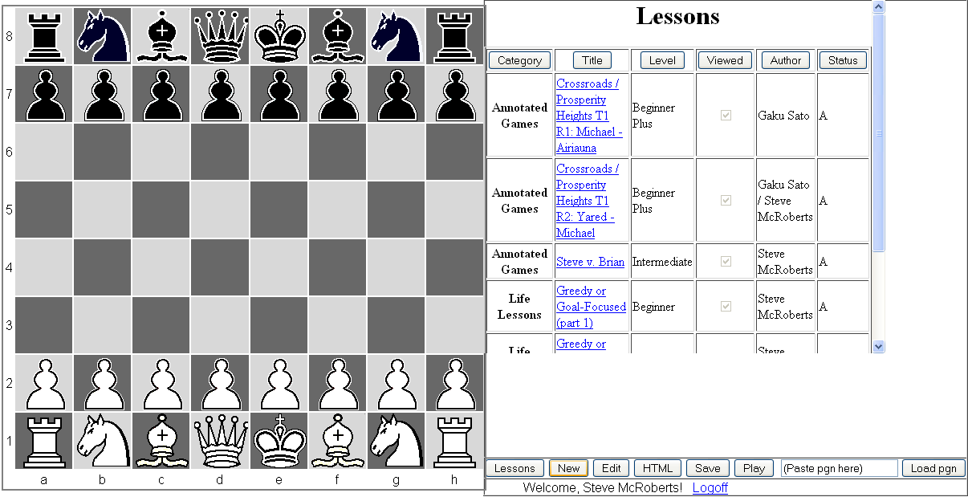

- Click on the New button. This will bring up the following screen:

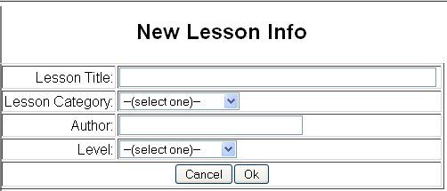

- Fill in all fields, and click Ok.
- This will take you back to the Lesson screen with the new lesson displayed in the list under the category you have chosen (with a status of “E” for empty.) No one else but you can see the lesson at this point.
- Click on the new lesson, and it will be shown in Play mode (as just a title and author).
- Click on the Edit button and begin to enter the lesson.

You may want to enter a starting-position (required, if not the standard starting position of a game, but always a good idea in case the student comes to your lesson with the board setup from a previous lesson.) To do this:

- Click on the page where you want the link to appear.
- Click on the POS button in the edit toolbar. The button will change to SET.
- Now rearrange the pieces, if needed (there is a Clear button if you want to clear all the pieces off the board – scroll down to see this button – then drag-and-drop the pieces from below the board onto the board.)
- When you are satisfied with the position, press the SET button: this will insert a “starting position” link.
- If you don’t like where the link was placed in the lesson, you can cut and paste it elsewhere.

If you have existing annotated games in pgn files, you can copy and paste them into the site, and they will be interpreted into a lesson which you can then modify.
- Simply open your pgn file in Notepad (or some other text editor),
- Select the entire document, and
- copy to the clipboard.
- Then paste into the site’s textbox labeled “(Paste pgn here)”.
- Finally, click the “Load pgn” button.
- You can now edit the game as you would a lesson you entered manually.

Be sure to Save your lesson frequently, so that your session does not time-out. For extra safety, you can periodically click on the HTML button, and copy and paste the entire HTML page into Notepad to save as a local file on your PC (a process you can always reverse in case the website’s Save fails.) When saving, you will be asked to enter a status-code, which is one of the following:
  - Draft (to continue working on later)
  - Submit for web-master approval (when finished)
  - Hold (to temporarily remove the lesson from the students’ lesson list)
  - Purge (to delete the lesson permanently)
Saving returns you to the Lesson list. Click on the lesson again to review the lesson and make sure your changes were saved.

After you have submitted a lesson for approval, the web-master will receive an email notification, and will (in time) approve or reject the submission. Once approved, the lesson will appear for all to see. If for some reason it is rejected, the webmaster will contact you with reasons and suggestions for changes (rejections will probably be extremely rare. The approval process is mostly to prevent inappropriate content entering the site from other people.) The webmaster may make slight formatting changes to your lesson (without affecting the content) just so it follows the same formatting standards as other lessons (such as capitalizing White and Black, and piece names, etc.)

After an approval, if you edit the lesson again, a new version will be saved in “S” (submitted) status. This allows students to continue viewing the original version until the new version is approved. In the meantime you will see both the original version (in “A” status) and your revision (in “S” status) on your list (students will only see the original (A status) version until approval: when the new version will replace the original version.)

If you discover a major mistake in an approved lesson, you can save it in Hold status; this will remove it from the students’ lesson list until the revised version is approved.

